List of things we would want to include in the Marketplace- UI

1. Airdrop
2. An education tab for educational platforms
3. Dollar value as well as crypto value
4. Memberships Tab
5. Events Tab
6. Tickets Tab
7. Loyalty programs tab
8. Nonprofit Tab
9. Verification for Businesses. The Blue Checkmark- KYC
10. Gaming Category
11. Taxes- under resources. The resources tab should come up
12. Something like this to show our features:

1. 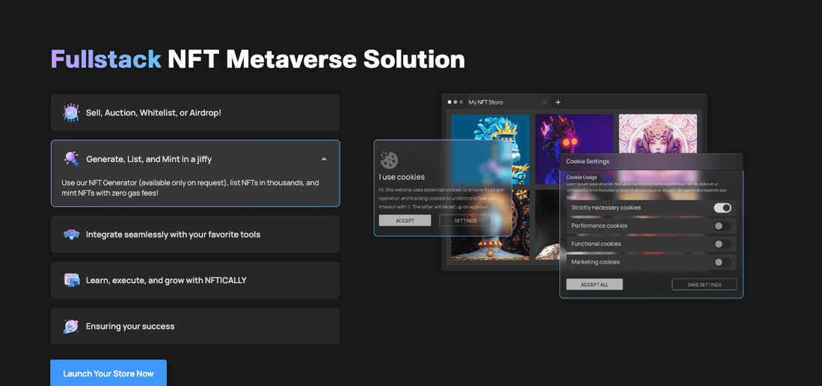Explains the solutions we have
2. Currency Option? If we can’t do the price next to it. It also has a chain option.

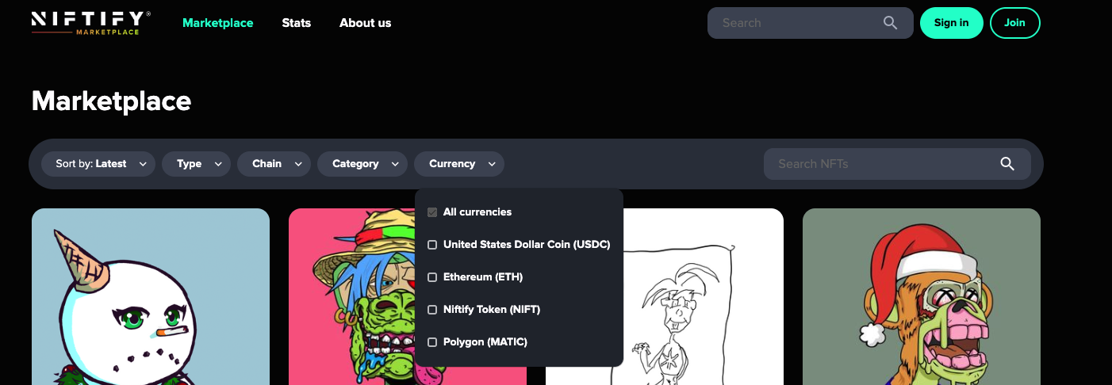

1. Redeemable NFTs: We will also need a redeem button for that store so when the NFT holder goes to redeem the physical product they are able to. Initially it can be an API on their website? <https://eips.ethereum.org/EIPS/eip-5560> ; <https://neftyblocks.medium.com/redeemable-nfts-are-live-5aae38a253b8>
2. Swap – Token, rewards, etc.
3. Vcommerce would be our ultimate goal (That product redeem etc. youtube video you shared)